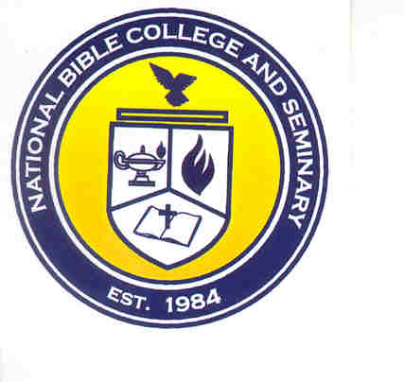
National Bible College & Seminary
6700 Bock Road
Fort Washington, MD 20744
Phone: 301-567-9503; Fax: 301-861-5371

Grace Fund Scholarship
Community Service Verification

Date: ______________________

Student Name: _________________________________________________________

Student ID: _____________________

Category: (Please select the one that applies for this verification.)

___ Group Home ___ Hospital

___ Nursing Home ___ Prison

___ Recreation Center ___ Other (please specify):

________________________________

Site Name: ____________________________________________________________

Address ______________________________________________________________

Frequency: ___________________________________________________________

This form must be completed by either the Ministry Director or the Site Manager.

___ Ministry Director ___ Site Manager

Name: _______________________________________________________________

Phone Number: _____________________ Email: __________________________

_____________________________________ ________________
Signature Date

_____________________________________ ________________
Student Signature Date

